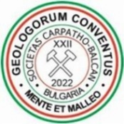 | XXII International Congress  of the Carpathian-Balkan Geological Association  7–11 September 2022, Plovdiv, Bulgaria | Form  C

GRANT APPLICATION FORM

The deadline for grant application is 1 June 2022

Please submit this form as e‐mail attachment to cbga2022@gmail.com

First name: | Last Name:
e-mail:
Institution (University, College, School):
Status:
Title of the abstract 1:
Mode of presentation:
Title of the abstract 2:
Mode of presentation:

Grant request for:

Registration Fee: Accommodation:

Organizing Committee signatures of Approval

Registration Fee: Accommodation:

President of CBGA2022:

